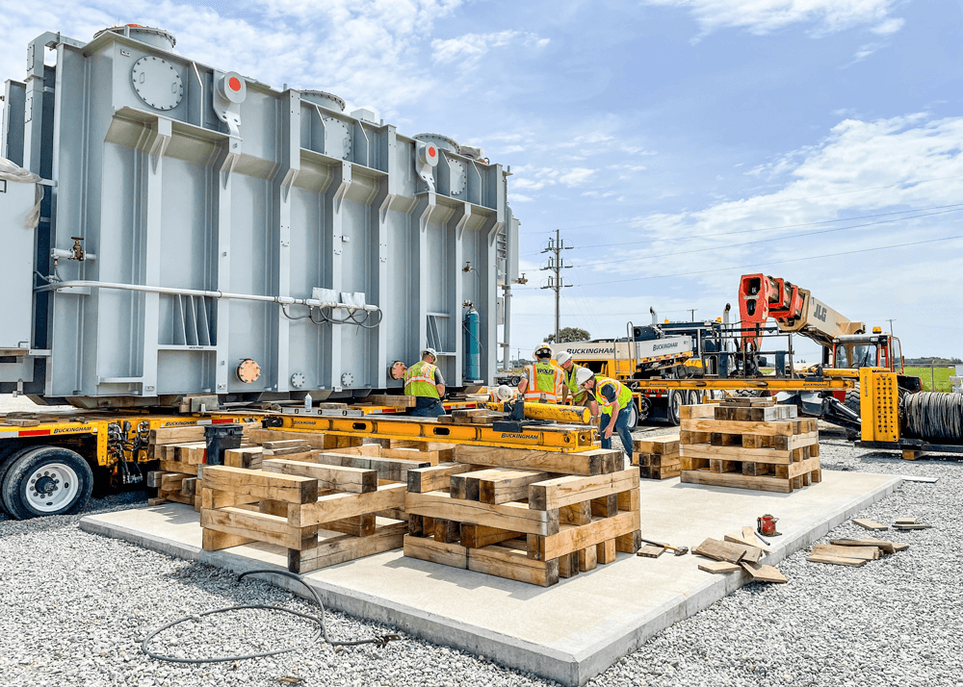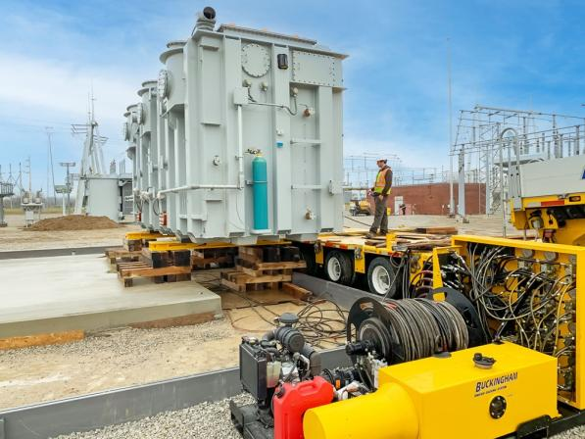
Introducing the Jack and Roll Skid Base for Transformers
In the world of electrical installations, efficiency and safety are key. That’s where the Jack and Roll Skid Base comes in—specifically designed to make the transportation and installation of transformers easier than ever.
What is the Jack and Roll Skid Base?
It’s a specialized base equipped with jack points for lifting and rollers for smooth movement. This feature ensures that even heavy transformers can be easily positioned without the need for cranes or extensive manpower.

Key Benefits:
- Ease of Mobility:
The integrated rollers allow for effortless movement across flat surfaces, simplifying the process of moving transformers into place—especially useful in tight spaces or difficult-to-access areas.
- Quick Installation:
No more complicated setups or heavy equipment needed. The jack points allow you to easily raise the transformer and adjust its position with precision. This cuts down on installation time and reduces the effort required on-site.
- Enhanced Safety:
Handling large transformers can be risky. The Jack and Roll Skid Base minimizes the need for manual lifting and reduces the risk of accidents by providing a controlled, secure method for moving and placing the transformer.
- Cost-Efficiency:
By reducing the need for heavy lifting equipment and minimizing labor, the Jack and Roll Skid Base helps lower overall installation costs.
- Flexibility:
Whether it’s a temporary installation or a permanent setup, this base offers greater flexibility in positioning and repositioning your transformer, making it a great asset for dynamic environments.

Why It’s Important:
In today's fast-paced installations, having equipment that is easy to transport and place accurately is a game-changer. The Jack and Roll Skid Base is designed to streamline this process, ensuring that your dry type transformers are installed efficiently, safely, and cost-effectively.
For professionals working in demanding environments, this accessory isn’t just a convenience—it’s an essential tool for getting the job done right!
Ready to take your transformer installations to the next level? Experience the difference with the Jack and Roll Skid Base today!

介绍变压器千斤顶和滚轮滑轨底座
在电气安装领域，效率和安全是关键。这就是千斤顶和滚轮滑轨底座的作用所在——专门设计用于使变压器的运输和安装比以往更加简单。
什么是千斤顶和滚轮滑轨底座？
这是一种专用底座，配有用于起重的千斤顶支点和用于平稳移动的滚轮。此功能可确保即使是重型变压器也可以轻松定位，而无需起重机或大量人力。
主要优点：
1. 移动方便：
集成的滚轮可轻松在平坦表面上移动，简化了将变压器移动到位的过程——在狭小空间或难以进入的区域尤其有用。
2. 快速安装：
无需更复杂的设置或重型设备。千斤顶支点可让您轻松抬起变压器并精确调整其位置。这缩短了安装时间并减少了现场所需的工作量。
3. 增强安全性：
处理大型变压器可能会有风险。千斤顶和滚动滑轨底座通过提供可控、安全的变压器移动和放置方法，最大限度地减少了手动起重的需要，并降低了事故风险。
4. 成本效益：
通过减少对重型起重设备的需求并最大限度地减少劳动力，千斤顶和滚动滑轨底座有助于降低总体安装成本。
5. 灵活性：
无论是临时安装还是永久安装，此底座在定位和重新定位变压器方面都提供了更大的灵活性，使其成为动态环境中的宝贵资产。

为什么它很重要：
在当今快节奏的安装中，拥有易于运输和准确放置的设备是改变游戏规则的关键。千斤顶和滚动滑轨底座旨在简化此过程，确保您的干式变压器安装高效、安全且经济高效。
对于在苛刻环境中工作的专业人士来说，此配件不仅是一种便利，而且是正确完成工作的必备工具！
准备好将您的变压器安装提升到新的水平了吗？今天就体验 Jack and Roll Skid Base 的不同之处吧！

